Assignment 2
The Solar Filament Segmentation Challenge
Training Data
We have 707 labelled images on our training data, we used K-Fold Cross-Validation, K-fold-cross validation uses validation folds within your training data, while the test data is kept separate for the final evaluation.
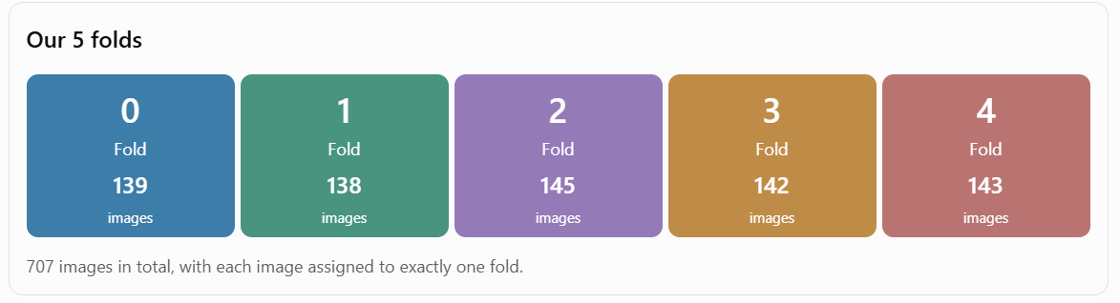
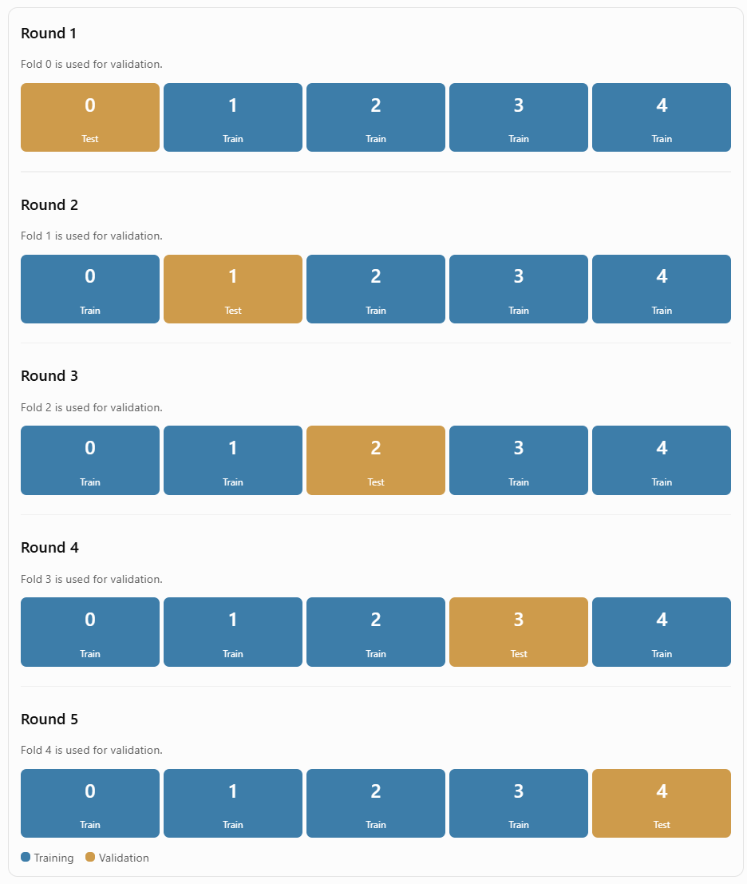
Every image gets a chance to be used for training, every image also gets a chance to be used for validation, no image is used for validation more than once, every round uses a different combination of training and validation images, this means we aren't judging our model based on just one lucky or unlucky split.
We use 5-fold cross-validation because we only have 707 labelled images. Instead of relying on just one train/validation split, we rotate the validation group five times. This allows us to evaluate the model on five different groups of unseen images and calculate an average validation score, giving us a better understanding of how well the model performs overall and how consistently it generalizes across different groups of images, and check whether it is potentially overfitting rather than genuinely learning patterns that generalize to unseen images.

Round 1 … Model training
We used round 1 to compare models (different architectures, losses and learning rates)
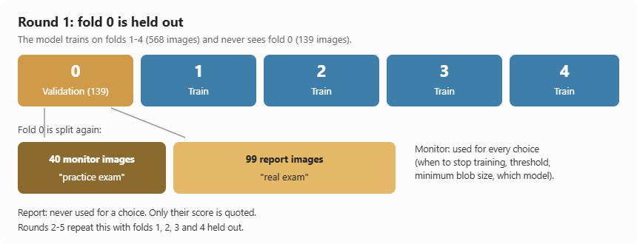
Fold 0 is simply the validation pile in Round 1: the model trains on folds 1–4 (568 images) and is checked on fold 0 (139 images) that it never saw.
Training one model takes about 20 minutes, so we couldn't run every experiment five times. We ran all 16 experiments (different architectures, losses and learning rates) in Round 1 only, so they were all compared on the same fold 0 images.
We then trained the winning model in Rounds 2–5 to check it.
Inside fold 0 we split the images again. 40 monitor images were used to make choices: when to stop training, the threshold, the minimum filament size and which model to keep. 99 report images were never used for any choice, only to quote the score
If you choose settings on the same images you report on, you pick whatever happens to suit those images, and the score looks better than it is. The monitor images are the practice exam, and the report images are the real exam.
What we learned: fold 0 turned out to be the easiest of the five folds. The model scored about 0.39–0.40 on fold 0, but only 0.343 on the hardest fold (fold 4). The fair number is the average over all five rounds, 0.368 ± 0.019. That is much closer to our Kaggle public score of 0.33.

Data Leakage????
The problem, a filament can last for days or weeks. The Sun turns once about every 27 days, so the same filament shows up in many images taken on nearby days. If Monday's image were in training and Tuesdays in testing, the model would be tested on a filament it has already seen. The score would look better than it really is.
The fix: we keep every image from one solar rotation together in the same pile. There are 130 rotations, with a median of 5 images each, no rotation is split across two folds. Example, rotation 2105 (9–19 January 2011) has 3 images, and all of them are in fold 1. As a result, a test image is typically 12–15 days away from the nearest training image, so the model mostly faces filaments it hasn't seen.
Limitation, where two rotations meet, a few validation images (3–8%) are within 3 days of a training image. A long-lived filament can cross that boundary

Balance????
The images come from six telescopes: Big Bear, Cerro Tololo, Learmonth, Mauna Loa, El Teide and Udaipur. They look different (brightness, sharpness, clouds). If one pile were mostly Udaipur, its score would mostly tell us about Udaipur.
So, when the rotations are dealt into piles, the split is also stratified by site, so every pile gets a fair mix of telescopes
Fold | Big Bear | Cerro Tololo | Learmonth | Mauna Loa | El Teide | Udaipur | Total
0 | 23 | 24 | 25 | 25 | 22 | 20 | 139
1 | 24 | 24 | 25 | 24 | 21 | 20 | 138
2 | 24 | 26 | 27 | 25 | 22 | 21 | 145
3 | 23 | 26 | 25 | 25 | 22 | 21 | 142
4 | 24 | 25 | 25 | 26 | 23 | 20 | 143

Split reject
- Random split: it leaks the same filament across piles.
- Split by year: the piles would be very unequal. 2014 has 102 images but 2020 has only 9.

Model creation …different architectures
Every model was trained under the same rules:
- the same Round 1 split (train on folds 1–4, check on fold 0), the same crops, augmentation, loss and learning rate;
- early stopping on the same 40 monitor images;
- scoring on the same 99 report images.

Model candidates …the different architectures we trained to pick the best as our model
Refences: Image Segmentation Models - GeeksforGeeks , Fully Convolutional Network Variations and Method on Small Dataset , What is Panoptic Segmentation? - GeeksforGeeks

- FCN-32s ("bare CNN"): a ResNet34 image classifier whose last layer is replaced by a per-pixel score, then stretched back to full size. It has no real decoder.
- FCN-8s: the same, plus scores from two earlier, more detailed layers.
- U-Net: an encoder that shrinks the image, a decoder that rebuilds it, and skip connections that pass fine detail straight across. We tried it with a ResNet34 encoder, with an EfficientNet-B3 encoder, and trained from scratch with no pretraining.
- U-Net++: a U-Net with extra, denser skip connections.
- FPN: combines predictions made at several scales.
- DeepLabV3+: uses "dilated" convolutions to see a wide area, plus a small decoder.
- PSPNet: pools the image at several region sizes. It's built for large objects.

Epoch
An epoch here represents 800 training samples, not one complete pass through the 568 original images.
The sampling process is
- Randomly select one of the 568 training images
- Randomly select one annotator's segmentation outlines to use as segmentation mask… Experts often disagree (two experts only agree at PQ 0.34). Picking a different annotator each time teaches the model the experts' shared view instead of copying one person
- Select a crop location, favoring filament regions (70%) … 30% of the time anywhere on the Sun's disk
This gives the model more opportunities to learn what filaments look like while still learning the surrounding background. If we randomly select crop locations without any preference, many crops might contain mostly background.
- Extract a 512 × 512 crop from original image and the corresponding region of annotation mask
- Apply random augmentations.
So, the goal is to improve generalization and prevent overfitting.
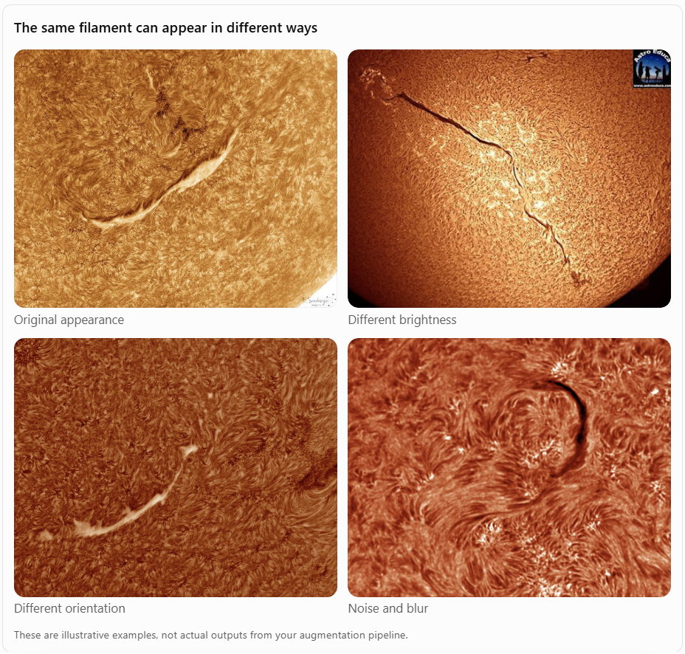
The model should learn to recognize the filament in all these situations.
This then means to us, when the image is rotated, flipped or resized, the corresponding mask must undergo the same geometric transformation.
We have two things
- Input image: The solar image crop.
- Ground-truth mask: The annotator's outline identifying the filament
So
Transformation | Image | Mask
Rotation | Rotated | Rotated identically
Flipping | Flipped | Flipped identically
Resizing | Resized | Resized identically
Brightness | Changed | Unchanged
Blur | Blurred | Unchanged
Noise | Added | Unchanged

- Repeat until 800 crops have been generated… while training the segmentation model…feed the image crop into the model, compare its predicted mask with the ground-truth mask, calculate the loss and update the model's weights.
Understanding the training dataset
We have 568 original training images (Round 1 on our k-fold). Each original image is 2048 × 2048 pixels. Each image has annotations (outlines drawn by annotators). The segmentation model receives smaller 512 × 512 crops instead of entire images.
512 was chosen by reasoning (filament length, GPU memory, model fit), not by testing several sizes.

- Why don’t shrink the image
Shrunk to | PQ of the labels | Filament width after shrinking
2048 (no shrinking) | 1.000 | ~11 px
1024 | 0.884 | 5.5 px
512 | 0.700 | 2.8 px
256 | 0.317 | 1.4 px

To test shrinking, we took the experts' perfect labels, shrank them, enlarged them back and scored them. A perfect label should score 1.0.
Filaments are only about 11 pixels wide. Shrink the image 4 times (2048 → 512) and they become about 3 pixels wide, and their shapes fall apart. The perfect labels then score only 0.700. Even a perfect model would lose 30% of the score before making a single mistake. So we keep the images at full size.

- Why the crop is 512 x 512
Crop size | Filaments that fit completely inside
2048 | 100%
1024 | 100%
512 | 99%
256 | 92%

A full-size image is too big to train on with our laptop GPU, so the model learns from pieces cut from it.
- 256 is too small: 8% of filaments would never fit whole in one piece.
- 1024 is too big: each piece costs 4 times the memory, so we could train on fewer pieces at a time, which is slower.
- 512 is the balance: 99% of filaments fit whole. We accept that the longest 1% are only ever seen in parts.
Those long filaments aren't thrown away: the model still trains on their parts. When predicting, overlapping windows slide across the whole image and the pieces are joined back together.

512 also suits the model: its encoder halves the image 5 times (512 → 16), so the size must divide evenly by 32.

Why 800 crops per epoch and not "every image once”??
We chose 800 crops as a fixed amount of training between check-ups on the monitor images. It works like a "check progress every 800 crops" rule, which is what early stopping needs…saves time
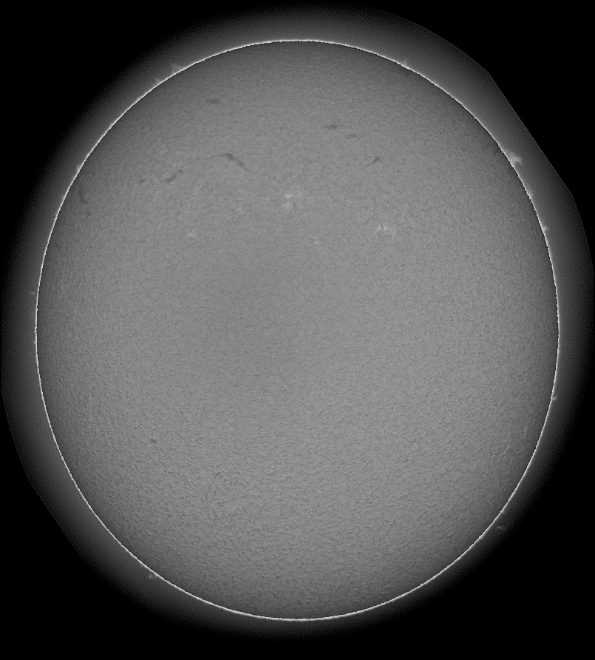
The image is 2048×2048 pixels, but only the round Sun disk matters; the black sky around it has no filaments. After our preprocessing, the Sun is a circle with a radius of about 905 pixels…Area of the disk = π × 905 × 905 ≈ 2,570,000 pixels
How big is one crop? ..512 × 512 = 262,144 pixels
How many crops cover one Sun? ...2,570,000 ÷ 262,144 ≈ 9.8, so about 10 crops
How many crops cover all 568 training images? … 568 images × 10 crops ≈ 5,680, so roughly 5,700
Early stopping
The problem, if we train too few epochs, the model hasn't learned enough (underfitting). If we train too many, it starts memorizing the training images, including each annotator's personal drawing style, and gets worse on new images (overfitting)
The fix: check after every epoch and stop when it stops improving.
- After each epoch (800 crops), score the model on the 40 monitor images.
- If the PQ is the best so far by at least 0.002, save the model. Smaller gains are treated as noise.
- If 2 epochs in a row bring no gain, halve the learning rate, so the model takes smaller, more careful steps.
- If 5 epochs in a row bring no gain, stop training.
- Never train more than 30 epochs.
- At the end, keep the saved best model, not the last one.

How PQ is calculated: PQ = SQ × RQ
The model gives each pixel a probability of being filament. We keep pixels above a threshold, and each separate blob that remains is one predicted filament. PQ then judges two things at once.
Step 1, matching. A predicted filament matches a real (expert) filament if their overlap is big enough:
- IoU = overlap area ÷ combined area, and a match needs IoU > 0.5.
- Above 0.5, each real filament can match at most one prediction.

This gives three counts:
- TP (true positive): a real filament matched by a prediction.
- FP (false positive): a prediction that matches nothing (an invented filament).
- FN (false negative): a real filament nothing matched (a missed filament).

Step 2, RQ (Recognition Quality): did we find the right filaments?
RQ = TP ÷ (TP + ½FP + ½FN)
This is the same as the F1 score. It drops when we miss filaments and when we invent them.
Step 3, SQ (Segmentation Quality): for the ones we found, how good are the outlines?
SQ = average IoU of the matched pairs (TPs only)
Since every match has IoU above 0.5, SQ is always between 0.5 and 1.
Step 4: PQ = SQ × RQ.
Worked example: our final model on the 99 report images.
- 732 real filaments were found (TP), 620 predictions were invented (FP), and 404 real filaments were missed (FN).
- RQ = 732 ÷ (732 + 310 + 202) = 732 ÷ 1,244 = 0.588
- SQ: the 732 matched pairs had an average IoU of 0.673.
- PQ = 0.673 × 0.588 = 0.396

Model results
Architecture | Main purpose
CNN classifier | Classify images
CNN encoder | Extract image features
CNN decoder | Reconstruct or generate outputs
CNN encoder-decoder | Image segmentation, reconstruction, denoising

A CNN does not automatically have an encoder and decoder. An encoder-decoder is a particular CNN architecture design.
if you're doing image classification, you typically only need the encoder (feature extractor) followed by a classification head BUT we doing segmentaion, often use both encoder and decoder.
CNN Encoder-Decoder Architecture…Unet
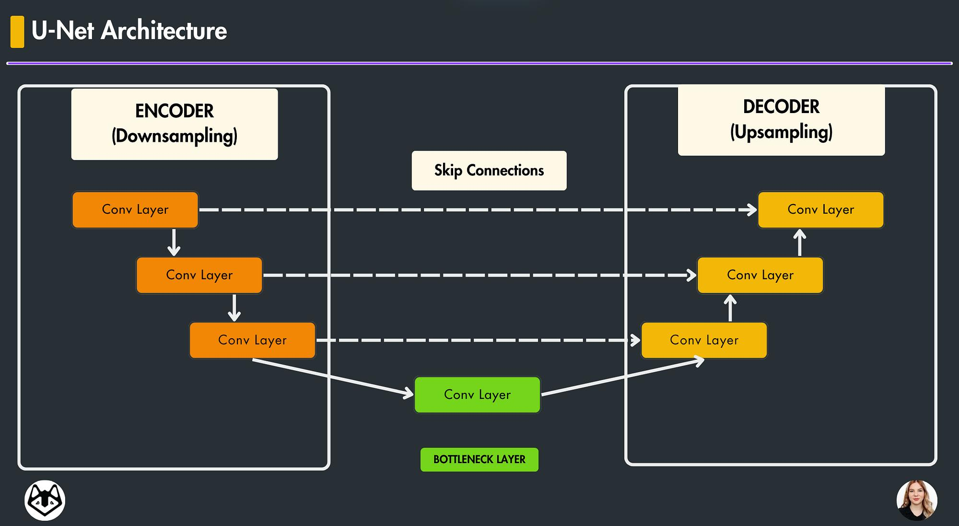
So which ones have encoder and decoder
DeepLab version.
- DeepLabV1: Does not have a conventional encoder-decoder structure.
- DeepLabV2: Uses Atrous Spatial Pyramid Pooling (ASPP), without a conventional decoder.
- DeepLabV3: Uses ASPP and typically upsamples the output; it does not have the full decoder of DeepLabV3+.
- DeepLabV3+: Uses an explicit decoder. ………………..
can check others Lusizo is tired
Encoder (backbone) | Decoder architecture
ResNet34 | U-Net decoder
ResNet50 | U-Net decoder
EfficientNet-B0 | U-Net decoder
EfficientNet-B3 | U-Net decoder
MobileNetV2 | U-Net decoder
Xception | DeepLabV3+ decoder
ResNet101 | DeepLabV3+ decoder

The two encoders
So We used ResNet34 as the encoder for almost every design, so the comparison is fair: same encoder, different decoder. U-Net was our planned baseline (REMBER KWENA talking about this ) , so it was the only design we also tried with a different encoder (EfficientNet-B3) and with no pretrained encoder (trained from scratch).
Both were already trained by their designers on ImageNet (about 1.2 million everyday photos), so they start out knowing edges and shapes. We only fine-tune them on our solar images. This is called pretraining.
- ResNet34: 34 layers. It has "shortcut" connections that let very deep networks train well (He et al., 2016). It's the standard mid-size encoder. 21.3M parameters.
- EfficientNet-B3: a family designed to get the most accuracy for the fewest parameters (Tan & Le, 2019). It uses cheaper convolutions. B3 is a middle size. 10.7M parameters, half of ResNet34.
**Our images are grayscale (1 channel) and ImageNet photos are color (3 channels), so the encoder's first layer is adapted to take 1 channel. **

Loss functions
The loss tells the model how wrong it is during training. We compared four losses on U-Net + ResNet34, with everything else the same
Loss function | What it does
Binary Cross-Entropy (BCE) | Pixel-wise classification
Dice Loss | Optimises region overlap
Focal Loss | Focuses on difficult pixels
Tversky Loss | Controls false positives vs false negatives
Focal Tversky Loss | Combines Tversky and focal weighting
clDice Loss | Encourages structural connectivity

We got this
Loss | Monitor PQ | Report PQ | What happened
BCE + Dice | 0.307 | 0.317 | Chosen: best on both image sets
Focal + Dice | 0.286 | 0.304 | 30% slower to train
Dice | 0.265 | 0.269 | Peaked early, then got worse
Tversky | 0.258 | 0.279 | Fewest broken filaments, but missed the most

- BCE (binary cross-entropy) checks each pixel separately: "is this pixel filament or not?"
- Dice measures the overlap between the predicted shape and the true shape.
Why the combination wins: filaments cover less than 1% of the image, and 13% of the training crops contain no filament at all. On an empty crop, Dice alone gives a weak, jumpy signal. BCE gives a steady signal on every pixel, and Dice keeps the model focused on the small filament area.
Later test (Enhancement): we added clDice, which compares the centrelines of the shapes so that a broken filament is punished. With the default settings it reduced broken filaments from 161 to 109. After tuning, its PQ (0.394) was no better than changing the seed, so it stayed an experiment.

The final model
All of these were trained the same way on round 1 (fold 0) with BCE+Dice loss, and scored with the default settings (threshold 0.5, remove blobs under 60 px).
Design | Encoder | Encoder params | Decoder params | Total | Monitor PQ | Report PQ
U-Net | EfficientNet-B3 | 10.7M | 2.5M | 13.2M | 0.312 | 0.309
U-Net | ResNet34 | 21.3M | 3.2M | 24.4M | 0.307 | 0.317
DeepLabV3+ | ResNet34 | 21.3M | 1.2M | 22.4M | 0.294 | 0.303
U-Net++ | ResNet34 | 21.3M | 4.8M | 26.1M | 0.284 | 0.304
FCN-8s | ResNet34 | 21.3M | ~0 | 21.3M | 0.268 | 0.266
FPN | ResNet34 | 21.3M | 1.9M | 23.1M | 0.265 | 0.269
PSPNet | ResNet34 | 21.3M | 0.15M | 21.4M | 0.246 | 0.237
U-Net | none (from scratch) | 7.8M total, not pretrained |  | 7.8M | 0.232 | 0.241
FCN-32s | ResNet34 | 21.3M | ~0 | 21.3M | 0.107 | 0.119

THE WINNER U-Net + EfficientNet-B3 …yeah
Limitation
EfficientNet-B3 was tried only with U-Net. We never tested it with DeepLabV3+ or U-Net++, so we can't say whether those designs would also improve with the smaller encoder.

